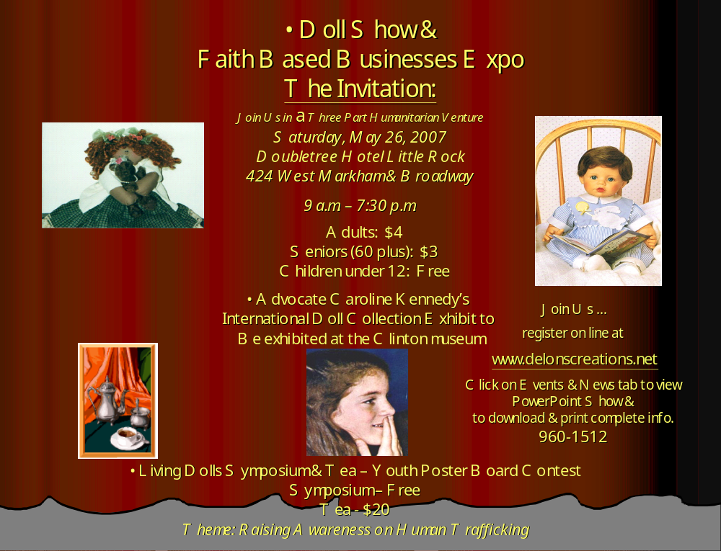



P. O. Box 325
Alexander, AR 72002-0325
www.delonscreations.net
delons_creations@yahoo.com
501-960-1512

Dear Friends:

“It’s coming! The event you’ve been waiting for! A doll show & faith based businesses expo in Arkansas!”

Hello. My name is Sharl Hill. I am chair of a doll show & faith based businesses expo in Arkansas for the year 2007 – 2008. I am working to have a joint venture doll show & faith based businesses expo in Arkansas. The expo’s theme is raising awareness of human trafficking. It will be held at the Doubletree Hotel, 424 West Markham & Broadway in Little Rock, Arkansas, Saturday, May 26, 2007. I also have ongoing communication with the Clinton Presidential Library regarding the possibility of bringing the Caroline Kennedy Doll Collection exhibit to the Clinton Library in 2008, 2009 or whenever possible.

In addition to bringing a doll show to Little Rock, I am having a “Living Dolls Symposium and Tea” during the expo to raise awareness of human trafficking in our country. The awareness will include viewing a movie, a symposium, and youth through a poster contest, all related to human trafficking. The winning posters will be exhibited at the symposium tea. Our committee will be conducting a survey to determine the interest and support of this event. Please review the enclosed survey. Vendor and poster board contest registration may be mailed in or entered on-line by clicking on the events & news tab at the above web site. For questions/concerns, contact me at the email address above. On behalf of the committee members, thank you so much for your time and interest.


Sincerely,

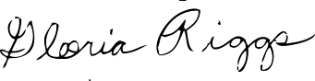
Sharl Hill, Faith Base Business Expo
& Doll Show Chair for Arkansas
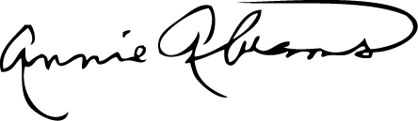
Gloria Riggs, C.U.R.E.
Citizens United for the Rehabilitation of Errants
Annie Abrams,
Communications Facilitator Archie Moore, JR
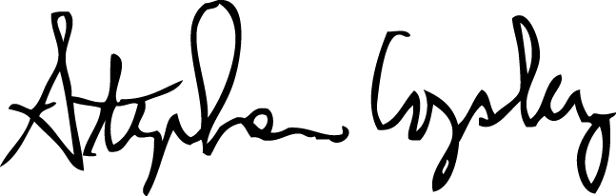
Archie Moore, Jr.
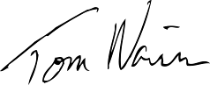
Antique Doll & Toy Exhibitor

Reverend Stephen Copley
President Interfaith Conference Tom Navin, Catholic Charities
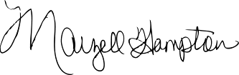
Social Action
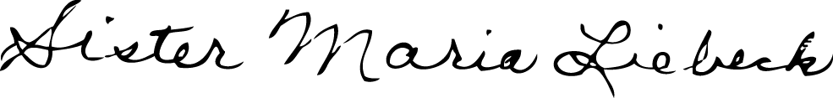

Marzell Hampton, Sister Maria Liebeck, President AR League Artist
Doll Exhibitor & Vendor Poster Board Contest Judge
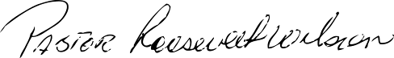
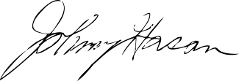

Pastor Roosevelt Wilson
Dominion Word Church/ Johnny Hasan, Panelist
Prayer – Deliverance Services Sgt. of Arms, House of Representatives
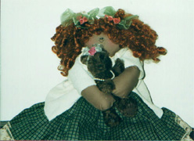
Survey
Part I

- Would you attend a “Living Dolls” symposium tea in the city
in efforts to raise awareness on a humanitarian issue such as human
trafficking, (modern day slavery)?
Yes No
- Do you believe you can gain an appreciation for information shared by attending this symposium tea in the city? You can be a part of the solution in raising awareness of human trafficking,
(a.k.a. modern day slavery) by showing support through your attendance.
Yes No
- Would you attend a doll show & faith based businesses/organizations expo where symposiums and a movie on human trafficking will be viewed throughout the day?
Yes No Uncertain
- Would you like to gain or increase your knowledge and history of dolls from
a world perspective through attending doll workshops if offered? Yes No
- What civic groups have you worked with primarily this year?

- Have you ever been to an antique show or a doll show? Yes No


- Does your church or organization facilitate or sponsor events such as this to raise awareness of human trafficking? Yes No
- What books on humanity interest you the most?
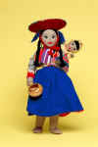
Humanity in Religion Humanity in Politics
Philanthropy Humanity in the Arts
- What issues concerning humanity are you interested in knowing more about?
Please list. Church’s, faith based businesses & organizations are especially encouraged to share your concerns, comments, & suggestions as this will help determine the theme for future faith based expos:

The following information on Human Trafficking and more will be discussed at the symposium tea panel discussion on the day of the event. Review the program line up to date enclosed for your information.

What are the Trafficking Victims Protection Act and the Trafficking in Persons Report?
Congress passed the Trafficking Victims Protection Act (TVPA) in 2000 and strengthened it in 2003. This law provides tools for the U.S. to combat trafficking in persons, both domestically and abroad.
The annual Trafficking in Persons Report serves as the primary diplomatic tool through which the U.S. Government encourages partnerships and increased determination in the fight against forced labor, sexual exploitation, and modern-day slavery.

Doll Show & Faith Base Business Chair
Date of return – 10 days
Call 960-1512 or Email if additional time is needed at
delons_creations@yahoo.com

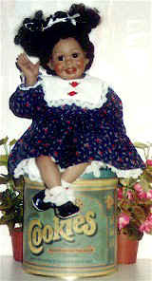
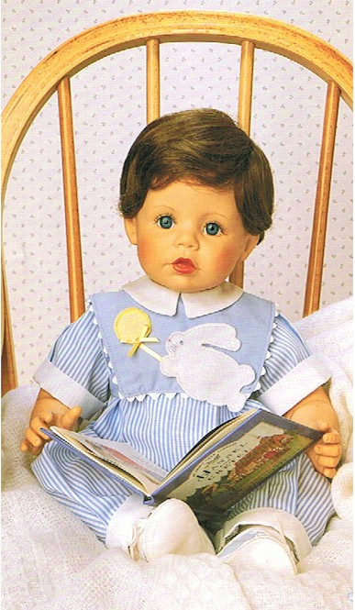
SURVEY
Part II

To: Civic Leaders, Doll Collectors, Faith Based Businesses,
and Advocates for Humanity.

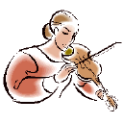
- Yes, I have an interest in doll shows and am a collector. I would like to be on the doll show & faith based businesses expo committee. I realize through my attendance I will help raise awareness of human trafficking through a humanity event such as this in Little Rock, AR.
Yes No Not sure at this time
- What antique interest do you have? Select 2 or more
Dolls Art Books Antique Cars Old time Gospel Albums
Furniture Dishes Silverware Sports Memorabilia
Clothing Shoes Jewelry Lamps Ceramic/Silver/Antique Tea Pots

- Would you attend a “Living Dolls Symposium Tea” where a youth award may be given for best poster board display depicting concepts that emphasize the fact that “Human Trafficking is Wrong”?
Yes No
- Register on line: I am a faith based owned business/organization and will be a vendor at this event. I would like to be a vendor or simply attend other humanity events such as this. I can also email questions or concerns at delons_creations@yahoo.com. I will register on line. Click on the Events & News tab at www.delonscreations.net.
Yes No
Register by mail: For participating doll vendors, faith based owned businesses/organizations, needing to register by mail, please complete the following. Business Name/Contact Person: Business Address: PH#: Fax#: Send along with your check made payable to Delon’s Creations, P.O. Box 325; Alexander, AR 72002-0325. Registration Fee Non-Refundable. You will receive a registration confirmation notice. Recent requests have been made to allow for more vendors. Each vendor space will include one 6’ X 30” skirted table with chairs. Vendor registration will cease when all spaces are filled as vendor spaces are limited and are filled on a first come, first serve bases.

Registration Fees for Doll Vendors and Faith Based owned businesses/Organizations.
Hotel charges for additional services. Check all that apply
$150/Internet Access
Indicate whether wired or wireless
$25/Phone line
$10/Power supply

Please check one
$80/Vendor
$40/Two vendors sharing a booth

Set up time at the Doubletree Hotel, Salons A, B, & C on 424 West Markham in Little Rock starts Saturday morning, May 26, 2007 from 7 a.m. to 9 a.m. Break down starts at 8:00 p.m. and ends @ 9:00 p.m. Saturday evening, May 26, 2007.
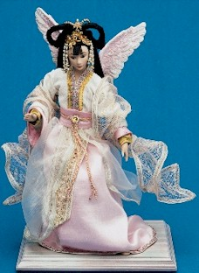
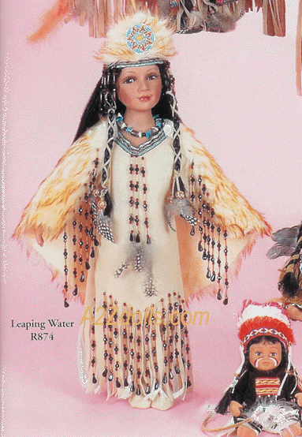
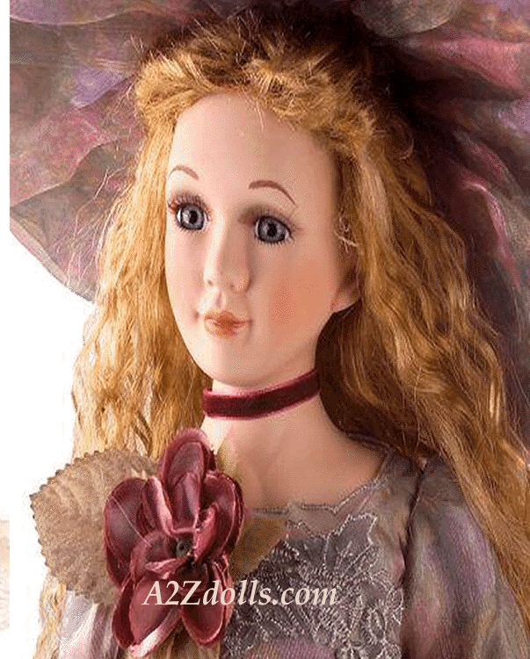

Lost and Found: Doubletree Security Department administers Lost & Found. The Hotel, Delon’s Creations, or any of it’s participants cannot be responsible for damage, stolen, or loss of any articles or merchandise.
Doll Show & Faith Based Businesses Expo
Program for
Saturday, May 26, 2007
Doubletree Hotel
Adults: $4
Seniors (60 plus): $3
Children under 12: Free
7 a.m. to 9 a.m.
Vendor /Exhibit Booths set up and check in

9 a.m. to 7:30 p.m.
Expo Open

9 a.m. to 11 a.m.
“Human Trafficking” Movie Part I

11:00 a.m. to 11:30 a.m.
Faith Based Businesses
By: Pastor Phil Murray / New Life Fellowship Church
Minister Timothy Carter from God’s Army Deliverance Center
Special Performance by Young Souljahz

11:30 a.m. to 1 p.m.
Lunch - on your own

1 p.m. to 3 p.m.
“Human Trafficking” Movie Part II

3:30 p.m. to 4:30 p.m.
Living Dolls Symposium & Tea
“Human Trafficking from Biblical Times to Today”
PSA’s on Human Trafficking

5:00 p.m.
The Evolution of Black Dolls in America
from the Turn of the Century Until Present Day
By: Mary Swift

Opportunities are available for
recommending future workshops.

Doll Show & Faith Based Businesses Expo Committee
Additional Bios of committee members added as requested

- Sharl Delon Hill
She has a beginning collection of dolls. In 2004, she attended a “Dolls of Color on Parade” show in New Carrollton, MD and wants to bring the show to Arkansas along with the Caroline Kennedy international doll collection exhibited at the Clinton Library. Her goal of having a faith based business & Doll show expo in Arkansas continues as she invites others to this joint venture.
- Annie McDaniel Abrams
Ms. Abrams is known for her far reaching community involvement. She is a life member of the NAACP, the Arkansas Education Association and the Arkansas Congress of Parents and Teachers.

Ms. Abrams is a member of the Daisy Bates Memorial Committee, the Martin Luther King Commission, the New Futures Executive Committee, the Vision Team 2000 Little Rock Housing Group, the National Council of Negro Women, and the AARP Leadership Council. She is the past chairperson of the Little Rock Biracial Committee. She has held numerous positions in the Democratic Party of Arkansas including Pulaski County Democratic Women, Senior Democrats, and she currently serves as treasurer of the Democratic Black Caucus.
Ms. Abrams acts as guardian to her grandchildren, and she is a member of Sigma Gamma Rho Sorority.
- Reverend Stephen Copley
Stephen Copley is the Sr. Pastor of North Little Rock First United Methodist Church. He has a B.A. degree from the University of Central Arkansas; a Master of Divinity degree from Southern Methodist University; and a J.D. degree from the University of Arkansas-Little Rock School of Law. He is also President of the Arkansas Interfaith Conference.
- Marzell Hampton
Marzell Hampton moved to Little Rock, Arkansas in March 1981 from Pine Bluff, AR. Pine Bluff is her home town.
Marzell started seriously collecting dolls about twenty two years ago. She now has well over 700 dolls. Her collection consists of Mexican dolls, White dolls, Black dolls, Asian dolls and the list goes on. The dolls date back as far as 1976. She now has future plans to display her doll exhibit.
- Sister Maria Liebeck
an artist in a variety of media. Her art ministry is for the Helping Hand Food Pantry in Little Rock. Her art can be seen in various galleries and art shows in the Greater L R. area She has degrees in art and is a member of the following organizations: Arkansas Arts Council, Art League of Arkansas, Arkansas Pastel Society. She most recently participated in judging art at the "Encuentro", (Encounter) which is a Hispanic religious art show sponsored annually
by the Catholic Diocese of Arkansas,
- Archie Moore Jr.
Archie Moore Jr. is a dealer in antiques and an avid collector with a personal interest in Black Americana. He has one of the largest collections of African-American memorabilia in the state of Arkansas. Moore donated his collection of African-American funeral programs to the Butler Center which compliments the Tom W. Dillard Black Arkansiana Collection, catalogued as MSS 03-01. He has exhibited Doll and Toy displays, developed the antique appraisal fair/show, and is the present Historian for the Afro-American Historical and Genealogical Society, Inc.
- Mary Swift
Mary Swift has been a local and regional doll collector for over 25 years. She has over a thousand black dolls that are antique and modern. She has done doll shows at the Decorative Art Museum, Dunbar, Robinson Convention Center, Ferndale 4H Center, and numerous churches. She has also been seen on channel 7 and 11 for her extensive collection. Her collection can be seen in the 1995 Dunbar Year book.


Youth Poster Contest!
Poster Rules & Helpful Guidelines
- Poster must demonstrate or promote images or messages showing compassion for victims of Human Trafficking, (Modern Day Slavery). Messages such as “Keep Children Happy, Not Trafficked” teaches children that their bodies are to be respected, and that they are to have a happy life, free from the oppression of trafficking. It may also encourage everyone on an international scale to pray for human trafficking victims.
- Spiritual messages such as the one on the Salvation Army’s poster “Set the Captives Free” are welcome.
  - Entry must be on 11” X 17” poster board, card stock, or artist drawing paper. No three-dimensional posters, computer scanned, or electronically generated images. Art Materials used can be crayons, markers, poster paints, water colors, etc.
Parents, please ensure the artist’s name, address, home phone number, grade level, church, school, city, and state is/must be printed on the back of the art work in the lower right corner. Only one entry per individual artist or student accepted.

- You may choose to pay and register on line at www.delonscreations.net. Click on the Events & News tab.
When mailing, write Do Not Bend on the envelope & add a piece of cardboard to the inside. Mail poster along with entry fee check, (unless paying on line), made payable to Delon’s Creations, c/o Poster Contest, P.O. Box 325, Alexander, AR 72002-0325. Questions – delons_creations@yahoo.com
Scale of Points Used
Originality 33 ⅓
Design 33 ⅓
Visual Appearance 33 ⅓
Winning posters will be displayed @
the symposium, Saturday, May 26, 2007.
Winners must be present to
obtain award. All posters must be
picked up no later than 7 p.m.
960-1512

Posters will be judged by:
Sister Maria Liebeck,
President of Arkansas League of Artists

To see this poster, just go to www.salvationarmyusa.org/usn/www_usn.nsf. Run the hand across the Services tab, Human Trafficking, First Annual International Weekend of Prayer & Fasting, etc., and click on the Prayer Day Poster.

Entry
Entry Fee:
1st through 6th grade $5
7th through 9th grade $10
10th through 12th grade $20

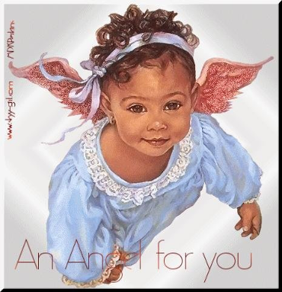


Living Dolls Symposium & Tea
Ticket purchase options (on line or through mail)
Symposium only - Free

Living Dolls Symposium & Tea  Saturday, May 26, 2007    at 3:30 p.m.  Doubletree Hotel  424 West Markham  Little Rock, Arkansas  Symposium only - Free  Tea - $20.00  $17 for early birds registering by April 14  For payees who are eating:  This ticket is your entry right  Retain and present ticket at door  Pay on line www.delonscreations.net  (click on Events & News)  Email questions at delons_creations@yahoo.com |  | By mail: Cut off this portion & send along with your $20 check made payable to  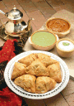  Delon’s Creations  Attn: Symposium Tea  P.O. Box 325  Alexander, AR 72002-0325  501-960-1512  Please Print  Name  Address  Zip Day Phone#  Evening phone #  Email  Amount enclosed $

